Troop 4 Web Site—How To Log In
Go to the Troop 4 web site in your web browser:
http://www.troop4milford.org
Scroll to the bottom of the middle column and click on “Login” under “Web Site Administration.”
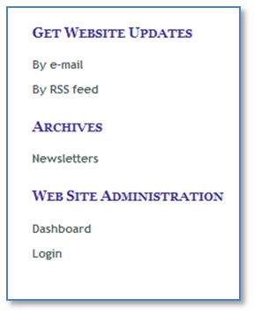
Enter the username and password you were provided. You can choose to click on the “Remember Me” box unless you are using a public computer, and then click on “Log In.”
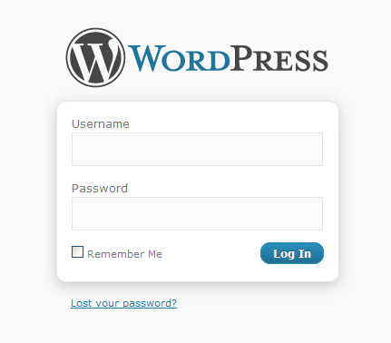
If you are successful you should find yourself at the web site “Dashboard.”
