Troop 4 Web Site—Managing Home Page Links
This document describes how to manage links on the site’s home page. These links appear in the center column of the home page:
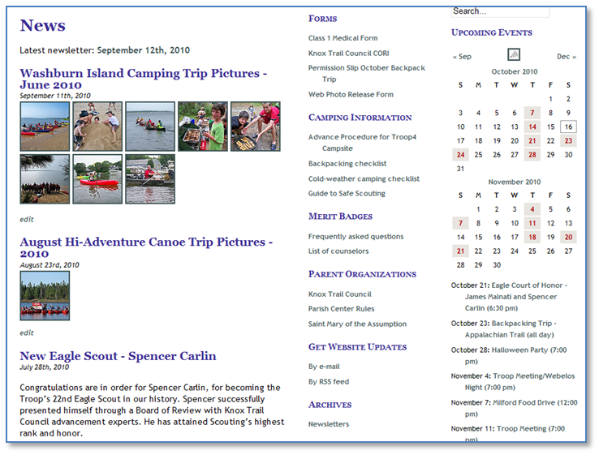
These links can be for any web location. They can take you to another site (such as “Knox Trail Council”), or to another page on the Troop 4 site (such as “Parish Center Rules”), or to a document on the Troop 4 site (such as “Web Photo Release Form”). These links are organized into several link categories, such as Forms, Camping Information, Merit Badges, etc.
Links in the center column should be reviewed each time a newsletter comes out. Delete stale links (such as old permission slips) and add new ones (such as new permission slips).
To manage home-page links you must first login to the web site. On the left side of Dashboard page, click on “Links” on the left:

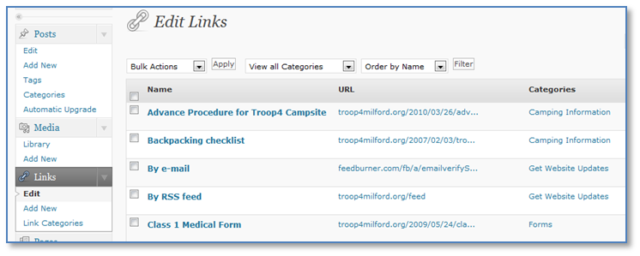

Adding a New Link
To add a new link to the home page, click on “Add New” under “Links” on the left side of the page.
This example will show how to add a link called “Web Photo Release Form” that points to the URL http://www.troop4milford.org/docs/2007/10/photo-release-form.pdf and that appears in the Forms link category.

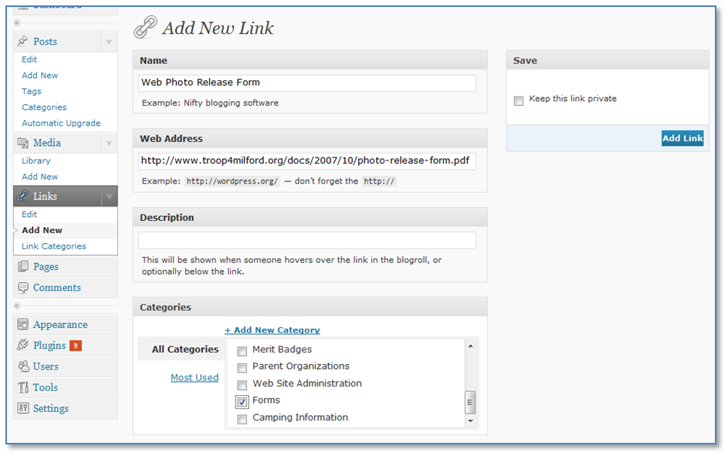
As shown in the highlighted areas above, type in the name of the link, the web address (URL), click on the appropriate Category box, and then finally click on the “Add Link” button.
Then go the home page of the site to verify that the new link appears in the proper category.

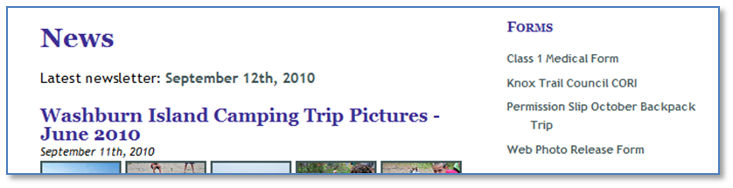

Deleting a Link
Links should be deleted when they get stale. For example, a link to a permission slip should be deleted after the event occurs.
The example here shows you how to delete a “Forms” link called “Camping Permission Slip – June 2010” on the home page.
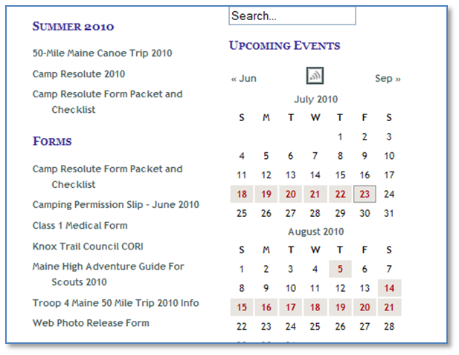

On the Dashboard, click on “Links” on the left side of the page.
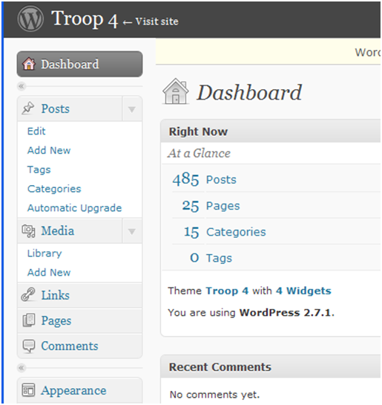
On the “Links” page, click on the name of the link you want to delete.
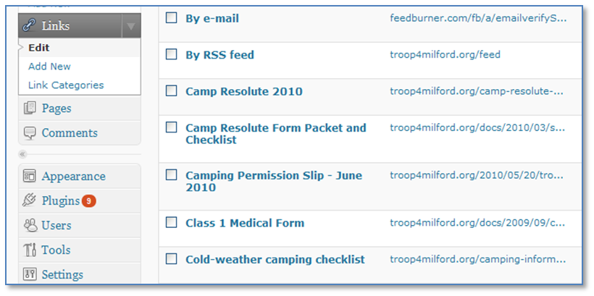

On the “Edit Link” page, click on “Delete.”
