Troop 4 Web Site—Posting a News Item
This document describes how to post a News item to the site’s home page. News items appear in the left column of the home page:
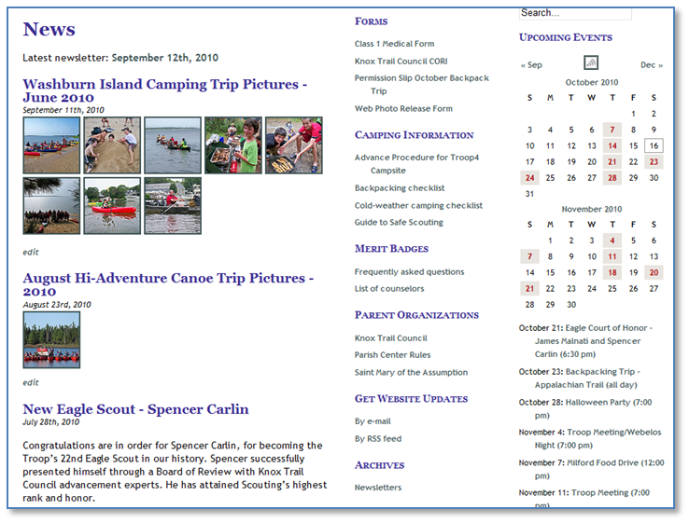
The most recent five news items appear on the home page.

To post a news item you must first login to the web site. On the left side of Dashboard page, click on “Add New” under “Posts.”
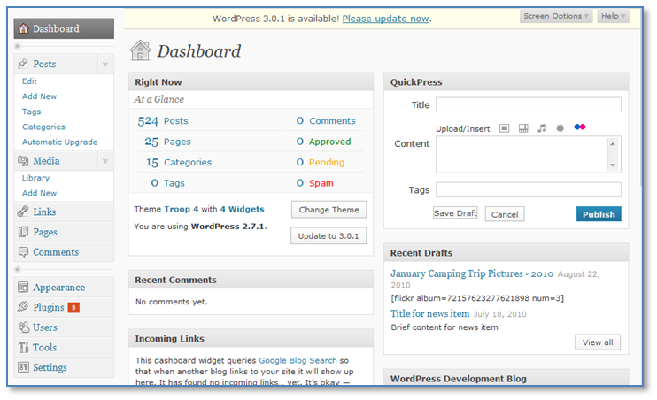
On the “Add New Post” page, enter a title and content, select the “News” category, and then click the “Publish” button as shown below. (Because of space constraints on the home page, keep the content of News items brief.)
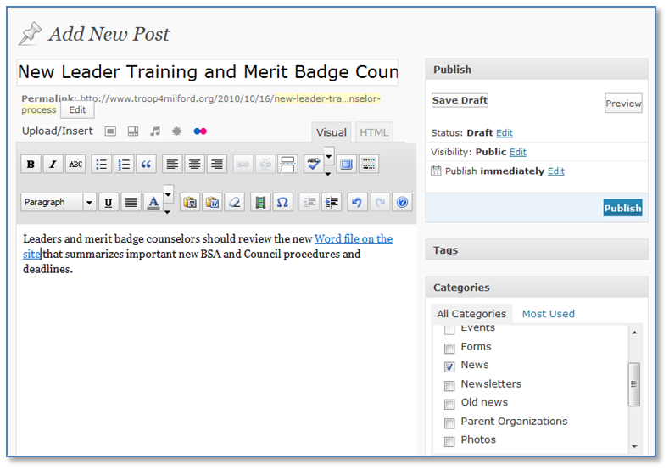

Finally, visit the site’s home page to verify that the News item appears correctly:

