Troop 4 Web Site—Posting a Permission Slip
This document describes how to post a permission slip to the site based on a permission slip from a newsletter Word file. You can use this sample newsletter file to experiment with.
First, login to the web site.
On the Dashboard, click on “Add New” under “Posts.”
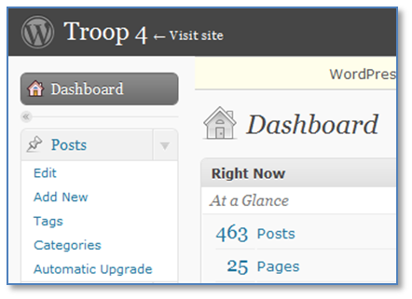

In the “Add New Post” screen, type in the name of the permission slip. Include the type of event, the month, and the year in the name of the post. For example, we’ll use “Permission Slip – Camping Trip – October 2010.”

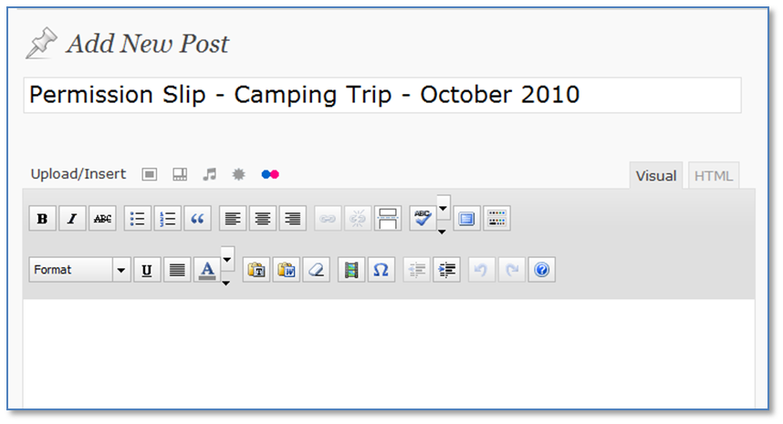
Open the Word file and go the page containing the permission slip. Select all of the text on the permission slip page except for the heading and copy it to the clipboard (Ctrl-C or Edit/Copy).
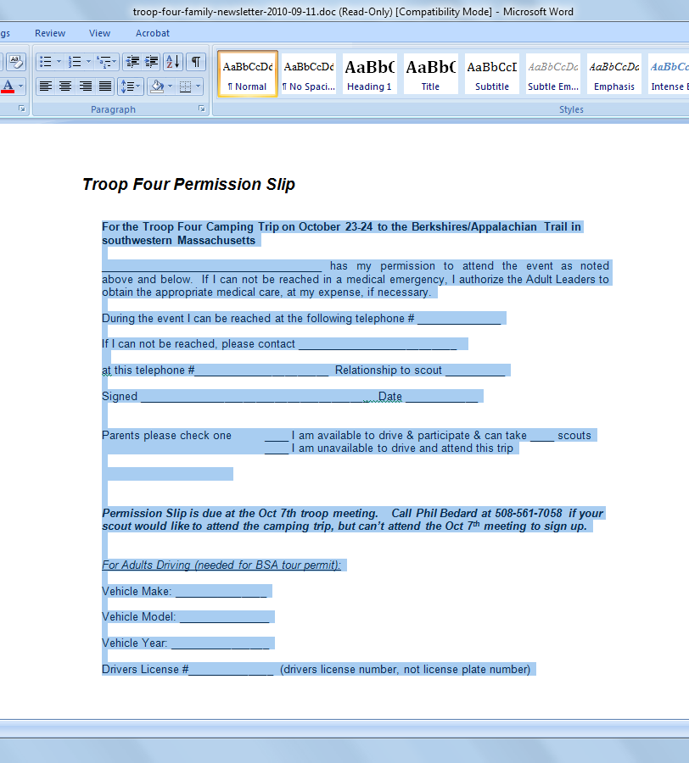
Now go back to the browser window where you are creating the new Permission Slip post. You don’t want to paste the text directly into the post, because Word includes too much crazy embedded HTML code that messes up the formatting on the site. Instead, click on the “paste as plain text” button on the toolbar.

In the dialog that pops up, press Ctrl-V to paste the permission slip text and then click on the “Insert” button.

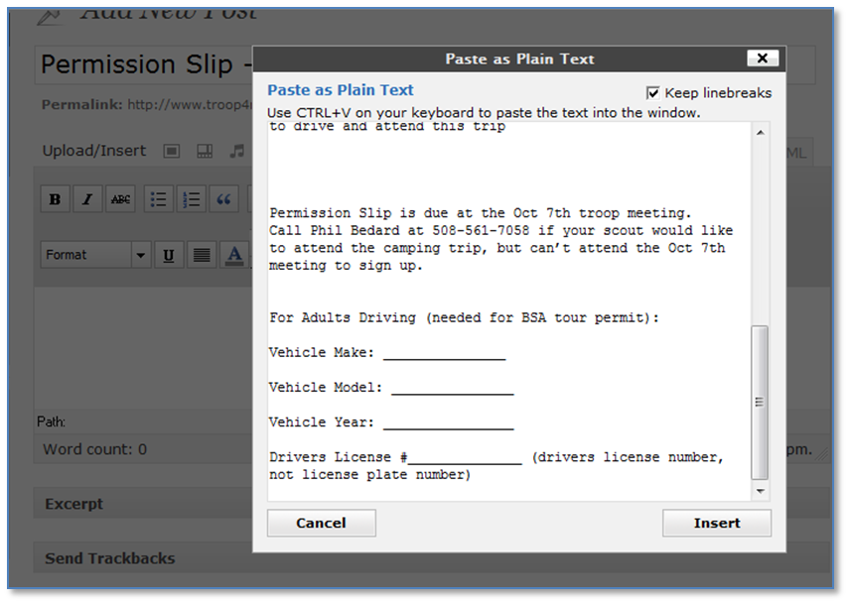

Finally, click on the “Publish” button.

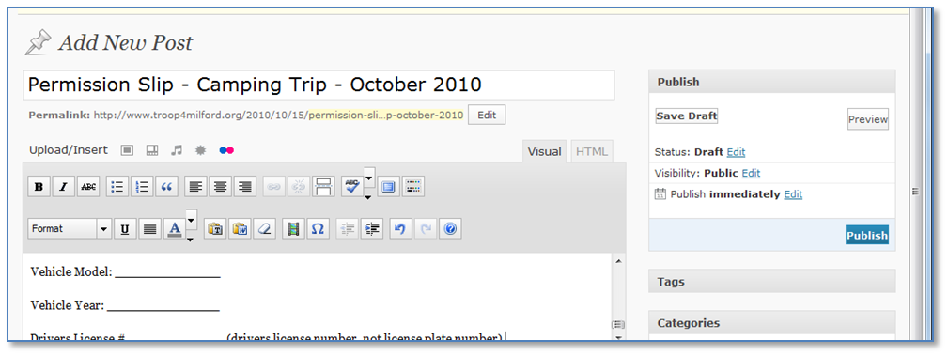
To view your published permission slip (and to get the link to it), click on the gray “Posts” bar on the left. Your new permission slip post should appear first. When you move your mouse pointer over it, you’ll see links for editing or viewing the permission slip.
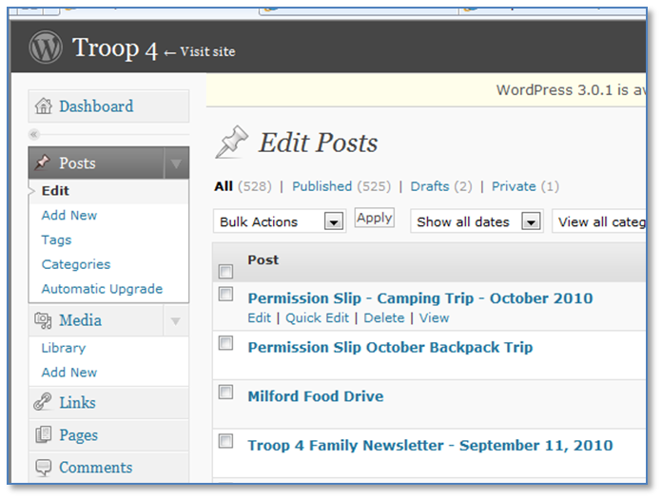

Clicking on “View” will bring up the new Permission Slip in your browser so that you’ll be able to get the link to it.

