Troop 4 Web Site—Uploading a File
This document describes how to upload a file (such as Word and PDF files) to the site.
First, login to the web site.
On the Dashboard, click on “Media” on the left side of the page. That will display the “Media Library” for the site.
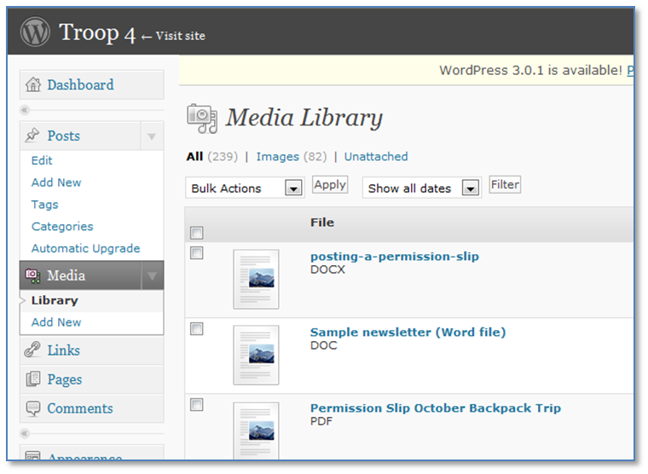
To upload a new file, click on “Add New” underneath “Media.” You’ll see this prompt below. Because the Flash uploader is flaky, click on the link that says “Browser uploader” instead.
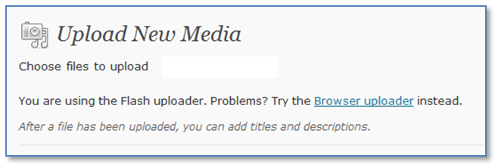

Now the page should look something like this:
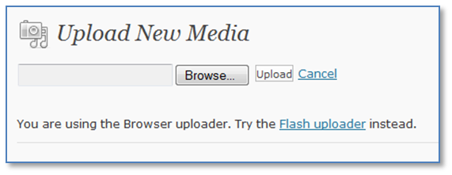
Click on the “Browse” button and find the file you want to upload on your computer. Then click on the “Upload” button.
After the upload is completed, the “Media Library” page should reload, and your new file should appear at the top.
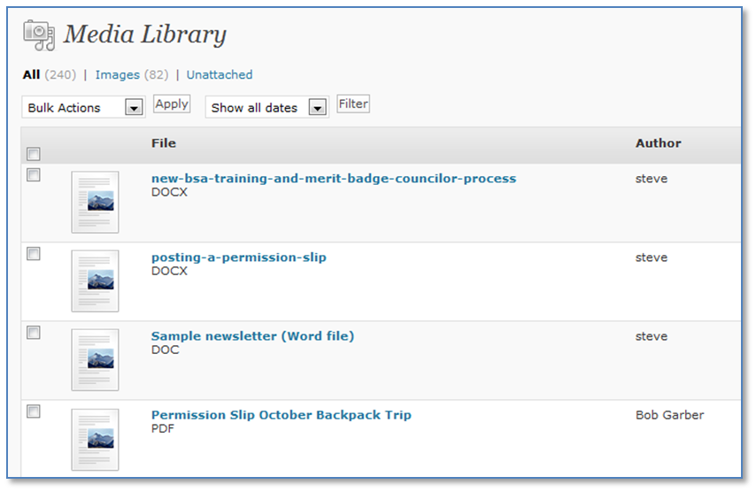
Now you need to get the URL of the uploaded file so that you can provide links to it from other places on the site.
Hover over the new media item and click on “View.”
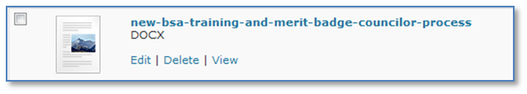

This takes you to a “pseudo-page” that is used to show the file’s link. The “pseudo-page” looks something like this:
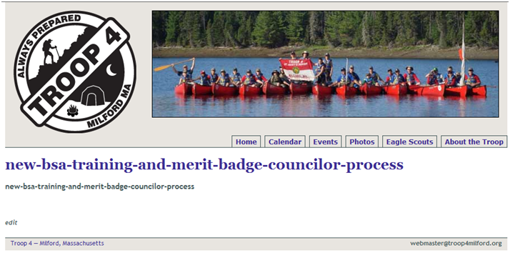
The highlighted line above is the link to the actual document that you uploaded. This is the link you want to use in other places on the site. Right-click on it and select “Copy shortcut” or “Copy link” (depending on which browser you are using). Then you can paste the link elsewhere. The URL should look something like this:
http://www.troop4milford.org/docs/2010/10/new-bsa-training-and-merit-badge-councilor-process.docx

