Troop 4 Web Site—How to Arrange Link Categories on the Home Page
This document describes how to arrange the link categories on the site’s home page. Links appear in the center column and are arranged by category.
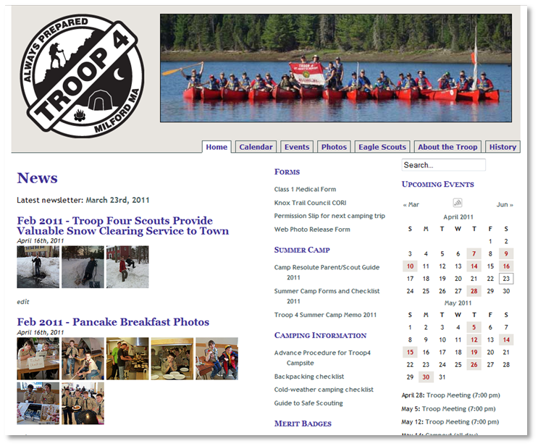
To change the order of the link categories you must first login to the web site. Then, on the left side of Dashboard page, click on “Links”. Then click on “Link Categories”.
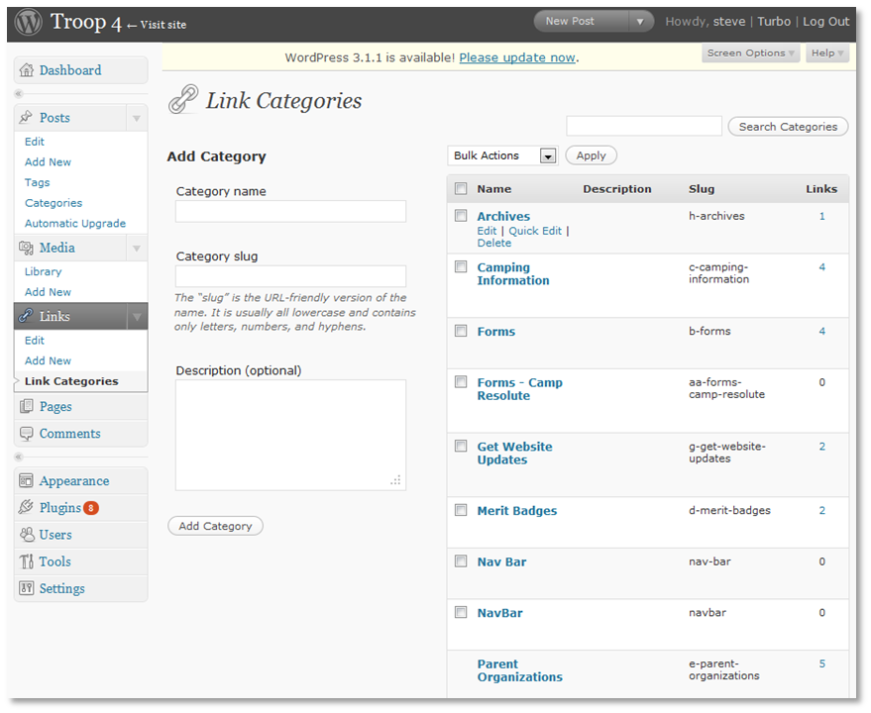
Link categories are sorted on the home page according to the link category “slug”. To change the order of a link category, edit the category and modify the slug.

